U1.Assignment1: INTRODUCTION TO MARKUP LANGUAGES

Search on the Internet for the answer to the following questions:

1. What is a Markup Language? Find a picture that describes it.

A markup language is a computer language that uses tags, for making content, and controlling its structure.

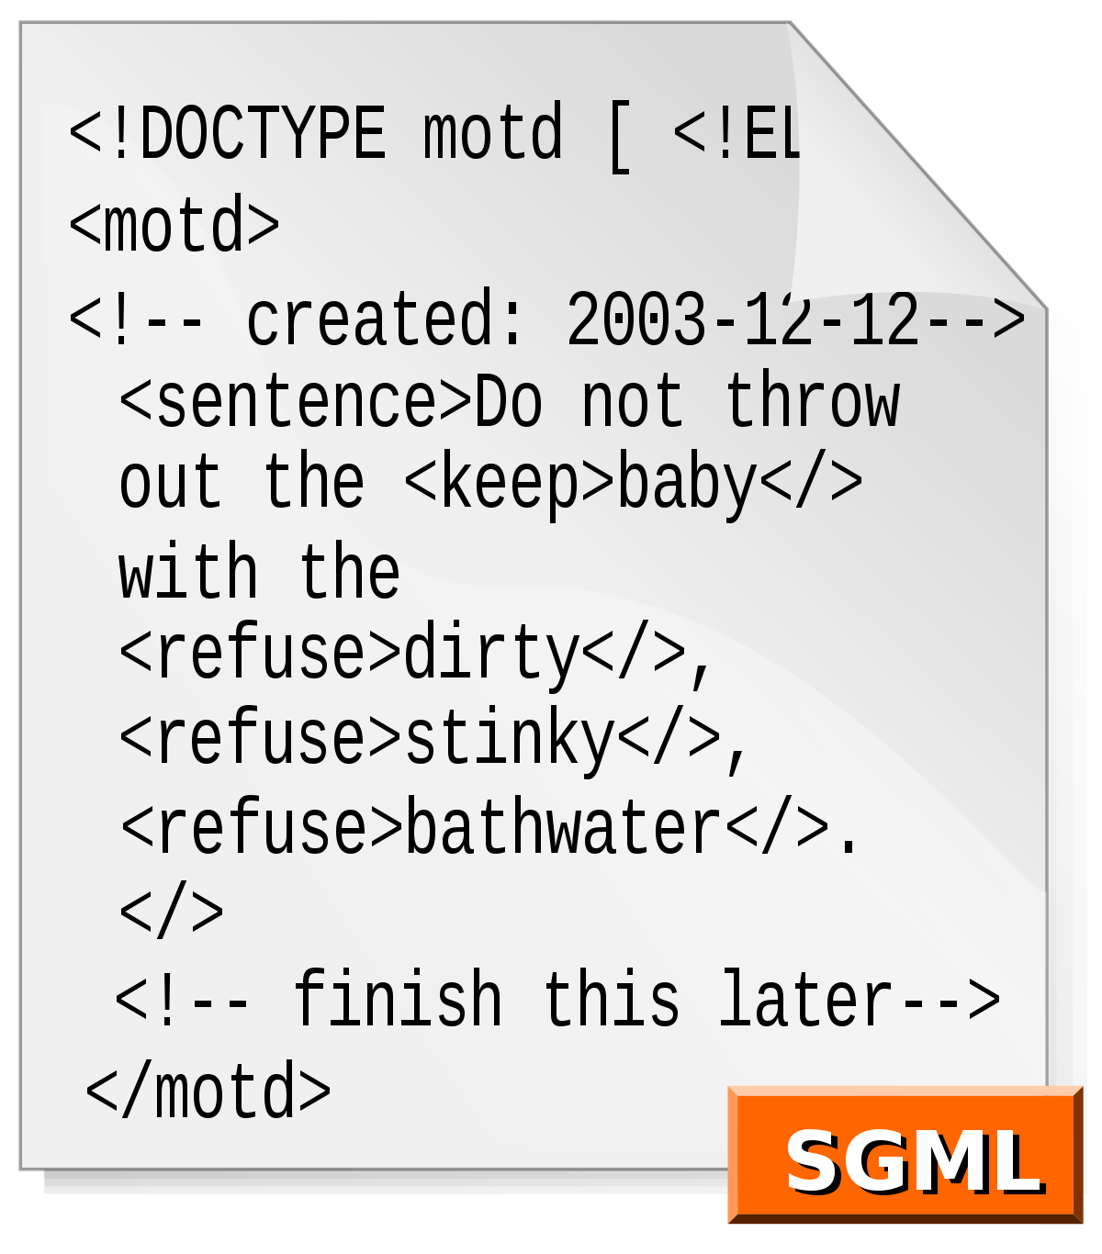

1. Differences between a programming language and a markup language. Build a table for comparing these two different types of languages

|  |  |
| --- | --- |
| **Markup Language** | **Programming Language** |
| System for annotating a document in a way in which is distinguishable from the text. | Formal language that contains instructions to produce various kinds of outputs. |
| Interpreted by the browser. | Need a compiler. |
| Used to present information. | Used to give instructions to perform a particular task. |
| A markup language controls the representation of data. | A programming language is used to manipulate the data. |

1. History of HTML: Find a video that explains it. Write a brief narrative summary of the content of the video.

In 1989 thanks to Tim Berners the internet became what we know today as the world wide web. Throughout the history of HTML there are some important dates: 1989 when the first version of it was published. In 1995 the 2.0 version came out with some improvements such us forms and tables. The 3.0 version appeared in 1997and included Netscape tags and some months after this the 4.0 with frames. In 2014 the 5.0 was published and it’s the one we use nowadays.

<https://www.youtube.com/watch?v=_lO1b_5lWHI>

1. Find a good description of:
   1. HTML: HyperText MarkUp language for tagging text files to achieve font, colour, and other graphical elements, used for webpage creation.
   2. CSS: Is a style sheet language used to manipulate elements already written by HTML or XML.
   3. XML: Extensible Markup Language, consists on a language that encondes documents in a way that make it readable by the machine and the user.
   4. JSON: Is a text format for exchange of data.
   5. JavaScript: Is a text-based programming language used both by the server and client side, used to create interactive content in webpages.
   6. Java: Is a programming language used for creating applications for different type of devices, is also used for creating data centres.
2. Tell which of the languages mentioned above are Markup languages, and what type of languages are the ones that are not.

Markup language : HTML, XML.

CSS: Style sheet language.

JSON: language-independent data interchange format

JavaScript, Java: Programming language.